Graphs for optimize.py:

Easy function: x2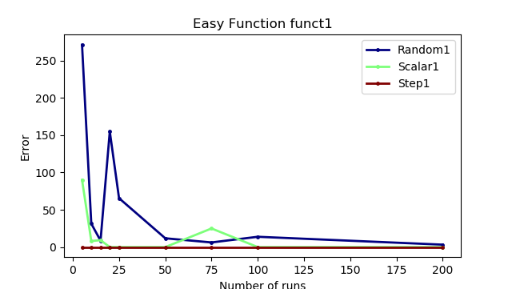

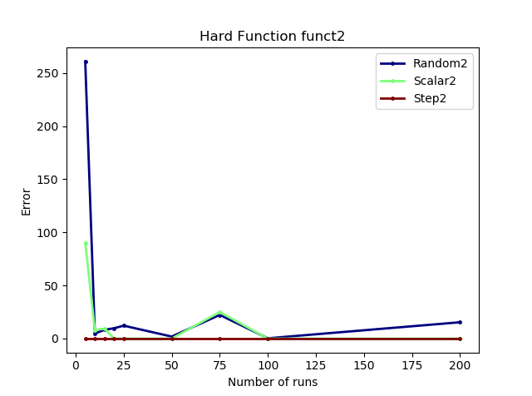Hard Function: x\*\*3 - (4\*x\*\*2) + (6\*x) + 5

Harder Function: 1/np.sqrt(2\*np.pi))\*np.exp(-(x\*\*2)/2

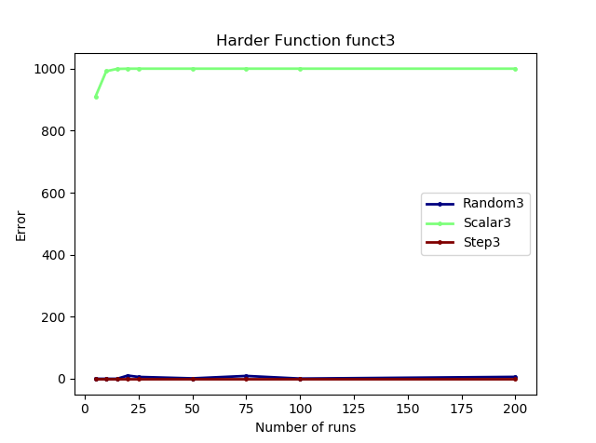

For this function, I don’t know why but for some reason the built-in- optimizer wasn’t performing well and there was a constant and large approximation error. Maybe because in this case the lower the x value the larger was the value of the function.

Graph for integrate.py:

